From Project Ideas to Investment Readiness

Renewable Energy Working Group 2023–2024

Connective Cities – Africa-Wide Municipal Energy Transition Platform

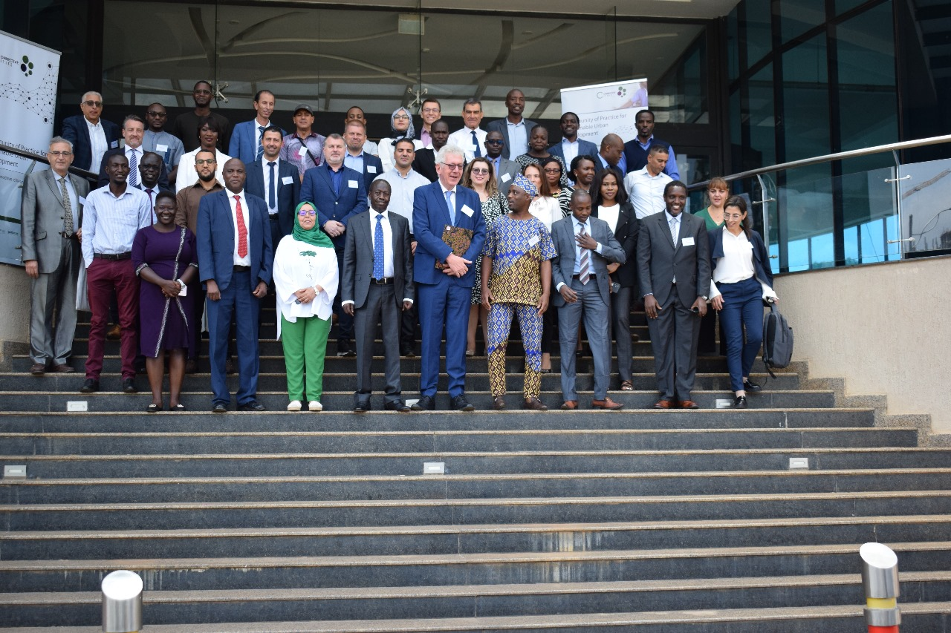

Executive Summary

Municipalities across Africa are increasingly positioning renewable energy as a strategic instrument for fiscal sustainability, climate mitigation, and service delivery reform. However, the transition from political ambition to investment-ready infrastructure projects remains structurally challenging.

The Renewable Energy Working Group (2023–2024), implemented under the Connective Cities platform, was designed as a practical acceleration mechanism to support municipalities in advancing renewable energy initiatives toward structured investment pipelines. The working group convened cities from across Sub-Saharan Africa and North Africa through peer-learning events in Nairobi, Dar es Salaam and Tunis. Rather than focusing on regional comparison, the initiative treated African municipalities as part of one emerging investment landscape.

Across participating cities, three dominant sectors of municipal renewable energy investment emerged:
- Street lighting and mobility-linked infrastructure
- Rooftop photovoltaic (PV) systems for public buildings
- Larger-scale PV and hybrid renewable concepts

Each sector reflects different levels of technical complexity, capital intensity, institutional demand and financing readiness.

Street lighting modernization, often through LED retrofitting and solar-powered systems, represents the most immediate and visible entry point for municipalities. Rooftop PV for public buildings demonstrates strong replicability and alignment with climate plans. Larger-scale PV plants and hybrid systems illustrate long-term ambition but require significantly stronger preparation frameworks.

Throughout the working group process, municipalities engaged directly with development finance institutions and technical partners. In Tunis, structured financing roundtables brought together representatives of AFD, EIB, AfDB, KfW, UNCDF and others. In Dar es Salaam, financing prerequisites and project bankability criteria were examined in depth. The Commune of Nefza subsequently submitted an application to the Gap Fund for project preparation support, illustrating the transition from workshop discussion to pipeline structuring.

The overarching lesson is clear: municipal renewable energy transition in Africa is not constrained by political will. It is constrained by structured project preparation capacity.
Connective Cities has demonstrated its role as an intermediary platform that bridges municipal ambition and development finance requirements. The next phase must deepen sector-specific bankability tracks and structured project clinics to transform concept portfolios into investment pipelines.

1. Municipal Renewable Energy as Infrastructure Reform

Municipal renewable energy is frequently framed as a climate mitigation measure. In practice, it functions as a broader infrastructure reform mechanism.
Across African municipalities, electricity expenditures represent a significant portion of operational budgets. Public lighting alone can account for 30–60 percent of municipal electricity consumption. Aging lighting systems, inefficient luminaires and grid dependency create fiscal pressure and service reliability risks.
Renewable energy interventions therefore address three simultaneous objectives:
- Cost reduction and fiscal stabilization
- Service reliability and public safety
- Climate mitigation and energy transition

The working group confirmed that renewable energy projects are rarely isolated technical interventions. They intersect with:
- Procurement frameworks
- Utility coordination
- Environmental permitting
- Budget planning cycles
- Urban mobility strategies

For municipalities, the renewable energy transition represents a shift toward asset management discipline, long-term planning and structured financial modeling.
The participating cities illustrate that renewable energy reform often begins with a visible entry project (e.g., LED street lighting) and gradually expands toward more complex PV or hybrid systems.

2. Sector I – Street Lighting and Mobility Infrastructure

Street lighting modernization emerged as the most prevalent renewable energy sector across participating municipalities. This sector combines high political visibility, direct cost-saving potential and manageable capital thresholds.

2.1 LED Modernization as Entry Strategy

Multiple municipalities presented LED transition projects, often combined with smart control systems.
The Commune of Nefza initiated a comprehensive LED replacement strategy integrated with smart lighting management. The project aims to reduce energy consumption while introducing digital monitoring. Following participation in the working group and financing dialogue in Tunis, Nefza submitted an application to the Gap Fund to secure structured project preparation support. This demonstrates a clear progression from concept to financing engagement.

Hammamet implemented partial LED retrofitting and complemented this with photovoltaic self-production ambitions. Energy audits conducted under national frameworks provided the initial technical basis for scaling.

Kasungu and Lilongwe proposed transitions from grid-based street lighting toward solar-powered systems, particularly in market areas where service reliability is critical for economic activity and safety.

Mwanza explored expansion and modernization of existing lighting infrastructure, recognizing both fiscal and urban security benefits.
Gulu emphasized solar lighting in green belt areas, demonstrating the integration of environmental and public safety objectives.

2.2 Mobility-Linked Renewable Infrastructure

The Dar es Salaam event introduced a mobility-linked renewable energy dimension. Cities such as Kisumu examined the integration of e-mobility charging infrastructure powered by renewable systems.
This sector expands the renewable energy narrative beyond static infrastructure toward dynamic urban transport transition. However, it also increases complexity:
- Higher capital requirements
- Grid interaction considerations
- Revenue model design
- Regulatory coordination
While mobility-linked renewable infrastructure remains at early conceptual stages in most municipalities, it signals an emerging second-generation renewable sector.

2.3 Investment Characteristics of Street Lighting Sector

Street lighting modernization typically exhibits:
- Moderate CAPEX
- Clear OPEX savings
- Strong political visibility
- Limited land requirements
- Replicability across municipalities

For development finance institutions, this sector represents a pragmatic entry point into municipal energy transition pipelines.
However, recurring gaps were identified:
- Absence of detailed feasibility studies
- Limited financial modeling of savings
- Weak O&M structuring
- Procurement planning gaps
The working group discussions emphasized the need to structure lighting projects not as isolated procurement actions but as multi-year investment programs.

3. Sector II – Rooftop PV for Public Buildings

Rooftop photovoltaic systems for municipal buildings constitute the second major renewable sector across participating cities.

3.1 Climate Plan Integration

Nabeul demonstrated alignment between rooftop PV projects and its municipal climate action plan (PAAEDC). The integration of PV investments into formal mitigation strategies strengthens policy coherence and financing credibility.

Mahdia installed PV systems on municipal sports complexes, targeting direct operational cost reductions.

Tozeur represents one of the most advanced preparation cases, having initiated partial installations and conducted structured assessments for scaling.

Nairobi and Baringo explored solarization of public facilities, including markets and administrative buildings.

3.2 Bankability Profile

Compared to larger-scale PV concepts, rooftop systems offer:
- Lower environmental permitting complexity
- Easier grid integration
- Phased implementation options
- Strong climate mitigation narrative

However, successful scaling depends on:
- Detailed energy audits
- Structural assessment of buildings
- Financial modeling of payback periods
- Procurement standardization
The working group reinforced that rooftop PV can evolve into portfolio-level investment programs if structured systematically across municipal assets.

4. Sector III – Larger-Scale PV and Hybrid Systems

The third sector reflects long-term ambition: centralized PV plants or hybrid renewable models supplying municipal infrastructure.

The Commune of Kef proposed a large-scale PV installation intended to supply public lighting infrastructure. With significant land availability and clear political commitment, the concept demonstrates scaling ambition toward energy self-sufficiency.

La Marsa introduced a hybrid model integrating waste-to-energy components within broader transition planning.

Baringo explored solar-powered water systems, illustrating the linkage between energy and service delivery.

4.1 Investment Complexity

These larger-scale projects involve:
- Land-use planning
- Environmental impact assessments
- Utility interconnection agreements
- High CAPEX thresholds
- Advanced financial modeling
While pipeline potential is significant, documentation and preparation gaps are most pronounced in this sector.
For development finance institutions, this segment represents medium- to long-term pipeline opportunities contingent on structured project preparation support.

5. Cross-Cutting Investment Readiness Barriers
Across all sectors, common barriers were identified:

5.1 Feasibility Gap
Many projects lack comprehensive technical feasibility studies including engineering design and lifecycle costing.

5.2 Environmental and Social Documentation
Environmental and social management plans are often underdeveloped at early stages.

5.3 Financial Modeling
Municipalities frequently present total investment figures but lack structured financial scenarios including OPEX, maintenance and co-financing.

5.4 Procurement Complexity
Public procurement regulations require early integration into project design to avoid implementation delays.

5.5 Institutional Structuring
Clear project management units and defined responsibilities are essential for scaling.
Importantly, these barriers reflect structural capacity constraints rather than political reluctance.

6. Financing Dialogue and Donor Engagement

The Tunis event included structured roundtables with representatives of AFD, EIB, AfDB, KfW, UNCDF and other financing actors. These dialogues clarified expectations regarding documentation, governance alignment and co-financing.
In Dar es Salaam, financing prerequisites were analyzed in detail, including environmental compliance and financial viability criteria.

The submission of the Nefza Gap Fund application demonstrates that the working group successfully facilitated transition from dialogue to structured financing engagement.
For AfDB and other development banks, the participating municipalities collectively represent a diversified pipeline across three renewable sectors.

7. Connective Cities as Pipeline Intermediary

The working group highlighted the intermediary role of Connective Cities:
- Structured project fiche methodology
- Peer-to-peer exchange as diagnostic tool
- Financing dialogue facilitation
- Bilateral technical clinics
- Integration of European best practices
Rather than acting as a funding mechanism, Connective Cities functions as a preparation accelerator, aligning municipal ambition with development finance logic.

8. Strategic Roadmap 2025–2026

To convert concept portfolios into structured pipelines, the next phase should include:
- Sector-specific bankability tracks
- Standardized feasibility templates
- Environmental documentation guidance
- O&M financial modeling support
- Continued financing roundtables
- Replication across additional African municipalities
Street lighting modernization offers immediate scaling potential. Rooftop PV can evolve into asset portfolios. Larger-scale PV concepts require targeted preparation facilities.

